|  |  |  |  |
| --- | --- | --- | --- |
| **Lyng Primary School Knowledge Organiser** | | | |
| **Geography Topic:** | **Australian Adventure**  Would you prefer to live in England or Australia? | Year 2 | Autumn |



**Fieldwork Opportunities**

Trip to the zoo.

Australia Bush tucker trial

|  |  |
| --- | --- |
| **What Step On and Goldilocks words will I use?** | |
| **Spelling** | **Definition** |
| Commonwealth | The UK and a group of countries that, in the past were ruled by the UK. |
| urban | Relating to a town or city. |
| indigenous | Originally from a place. |
| descendants | People from later generous |
| migrants | People who have moved to a different country |
| sacred | Holy |
| vast | Huge |
| Aboriginal people | The people indigenous to Australia |
| remote | Far away and hard to reach |
| marsupials | Mammals that carry their young in their pouches |
| rural | Relating to the countryside |
| reef | A ridge just below the surface of the water. |
| marine | Relating to oceans and seas |
| temperate | Rarely extremely hot or cold |
| settlement | A place where people have come to live. |

**Background information for parents and teachers**

Australia is the smallest continent of the seven continents and many consider it as the largest island in the world. Greenland, however, is the biggest island country. Australia is the sixth largest country in the world, after Russia, Canada, USA, China and Brazil. Its official name is the Commonwealth of Australia. It is part of the Commonwealth and sees Queen Elizabeth II as its queen. It has a democratic government and a population of around 25 million, 90 per cent of whom live in urban areas. Its capital city is Canberra and its official language is English. The currency is the Australian dollar. Its official national emblem is a golden wattle (a flower) but many use the kangaroo. It celebrates a national holiday on 26 January (Australia Day).

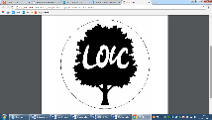

**Significant places**

* Australia
* Sydney
* The Great Barrier Reef
* The Outback

|  |
| --- |
| **Geographical skills** |
| * Ask and answer questions about a place. * Identify the key features of a location. * Use aerial maps to identify features. * Understand the similarities and differences between a small area of the UK and a non-European country. |

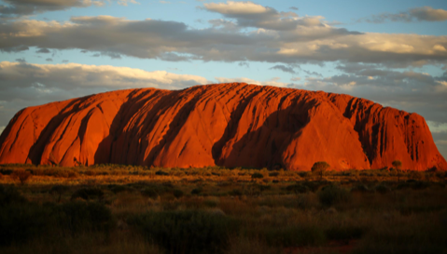

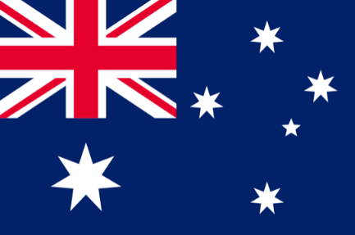

**Our Storytelling Approach to enhance engagement**

|  |  |  |
| --- | --- | --- |
| **People:**  The Aboriginal people | **Place:**  Australia | **Problem:**  British Empire grew and took over the country. |

**Map to be studied**

**Key facts and locations**

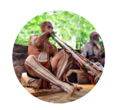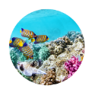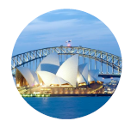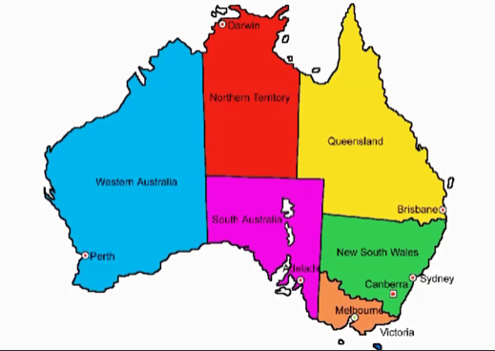

**Key Questions – sequence of learning**

* Australia is a continent and a country in the Southern Hemisphere. It is surrounded by the Indian ocean and the Pacific Ocean.
* The country is two-thirds desert landscape which is often referred to as the ‘Outback’
* The highest mountain in Australia is Mount Kosciuszko.
* Ayers Rock, also called Uluru, is the largest lone standing rock in the world.
* The longest river in Australia is the Murray River which is 1,558 miles long.
* The Great Barrier Reef in eastern Australia is the biggest coral reef in the world. It consists of more than 3000 reefs in which more than 350 species of corals and over 1500 species of fish live.
* The country is divided into six states (South Australia, Western Australia, New South Wales, Queensland, Victoria and Tasmania) and two self-governing territories (Northern Territory and Australian Capital Territory)
* Some Aboriginal people still live in villages in the sacred area around Uluru.
* Sydney is built around Sydney Harbour.
* The first people to live in Sydney were the Aboriginal people.
* The Sydney Harbour Bridge and the Opera House are the best known attractions.

**Agreed Outcome**

Write a postcard from an Australia.

Create a map of Australia showing the well known landmarks.

Compare the weather in the United Kingdom to Australia.

* Where in the world are countries from the Commonwealth?
* What countries are in the Commonwealth?
* What states are there in Australia?
* What landmarks are in Australia?
* *How does the Australian outback compare to West Bromwich?*
* How does the weather in Australia compare to the UK?
* How is the Australian dialect different to ours?
* How does the temperature change for each season in the U.K and Australia?

|  |  |  |  |
| --- | --- | --- | --- |
| **Lyng Primary School Knowledge Organiser** | | | |
| **Topic: Geography** | **Australia** | Year 2 | Autumn |

|  |  |  |
| --- | --- | --- |
| 6. How many continents are there in the world? | **S** | **E** |
| 5 |  |  |
| 6 |  |  |
| 7 |  |  |

|  |  |  |
| --- | --- | --- |
| 7. What is Uluru? | **S** | **E** |
| A large rock |  |  |
| A tall tree |  |  |
| A big house? |  |  |

|  |  |  |
| --- | --- | --- |
| 1. Which of these is a human landmark in Australia? | **S** | **E** |
| Uluru |  |  |
| Buckingham Palace |
| Sydney Opera House |

|  |  |  |
| --- | --- | --- |
| 1. Is Australia a country or a continent or both? | **S** | **E** |
| Country |  |  |
| Continent |  |  |
| Both |  |  |

|  |  |  |
| --- | --- | --- |
| 1. Which of these is a physical landmark in Australia? | **S** | **E** |
| Sydney Harbour Bridge |  |  |
| Great Barrier Reef |  |  |
| The Pyramids |  |  |

|  |  |  |
| --- | --- | --- |
| 1. What is the capital city of Australia? | **S** | **E** |
| Sydney |  |  |
| Canberra |  |  |
| Queensland |  |  |

**Australia**

**Quick Quiz**

|  |  |  |
| --- | --- | --- |
| 1. Which ocean surrounds Australia? | **S** | **E** |
| Atlantic |  |  |
| Pacific |  |  |
| Indian |  |  |

|  |  |  |
| --- | --- | --- |
| 1. What does indigenous mean? | **S** | **E** |
| Old |  |  |
| Originally from a place |
| Relatives from long ago |

|  |  |  |
| --- | --- | --- |
| 1. How many states are there in Australia? | **S** | **E** |
| 6 |  |  |
| 7 |  |  |
| 10 |  |  |

|  |  |  |
| --- | --- | --- |
| 1. What lives in the Great Barrier Reef? | **S** | **E** |
| Horses and sheep |  |  |
| Lions and tigers |  |  |
| Fish and coral |  |  |